

**CSE302: Database Systems (Section No: 06)**

**Fall 2024**

**Project Report**

Car Rental Service

[***project-installation-file-link***](https://github.com/XhAfAn1/Rental-Car-Desktop-Application/tree/main/Setup%20Files)

[***source-code-link***](https://github.com/XhAfAn1/Rental-Car-Desktop-Application/)

**Submitted by:**

|  |  |  |
| --- | --- | --- |
| **Student ID** | **Student Name** | **Contribution Percentage** |
| 2022-3-60-045 | MD. Saiful Islam | 30% (database, application) |
| 2022-3-60-144 | Rafsan Zani Niloy | 25% (ER diagram, database) |
| 2022-3-60-317 | Umme Mukaddisa | 25% (database, application) |
| 2022-3-60-205 | Zarif Syndeed Sikder | 20% (ER diagram,database) |

# E-R Model of the Project

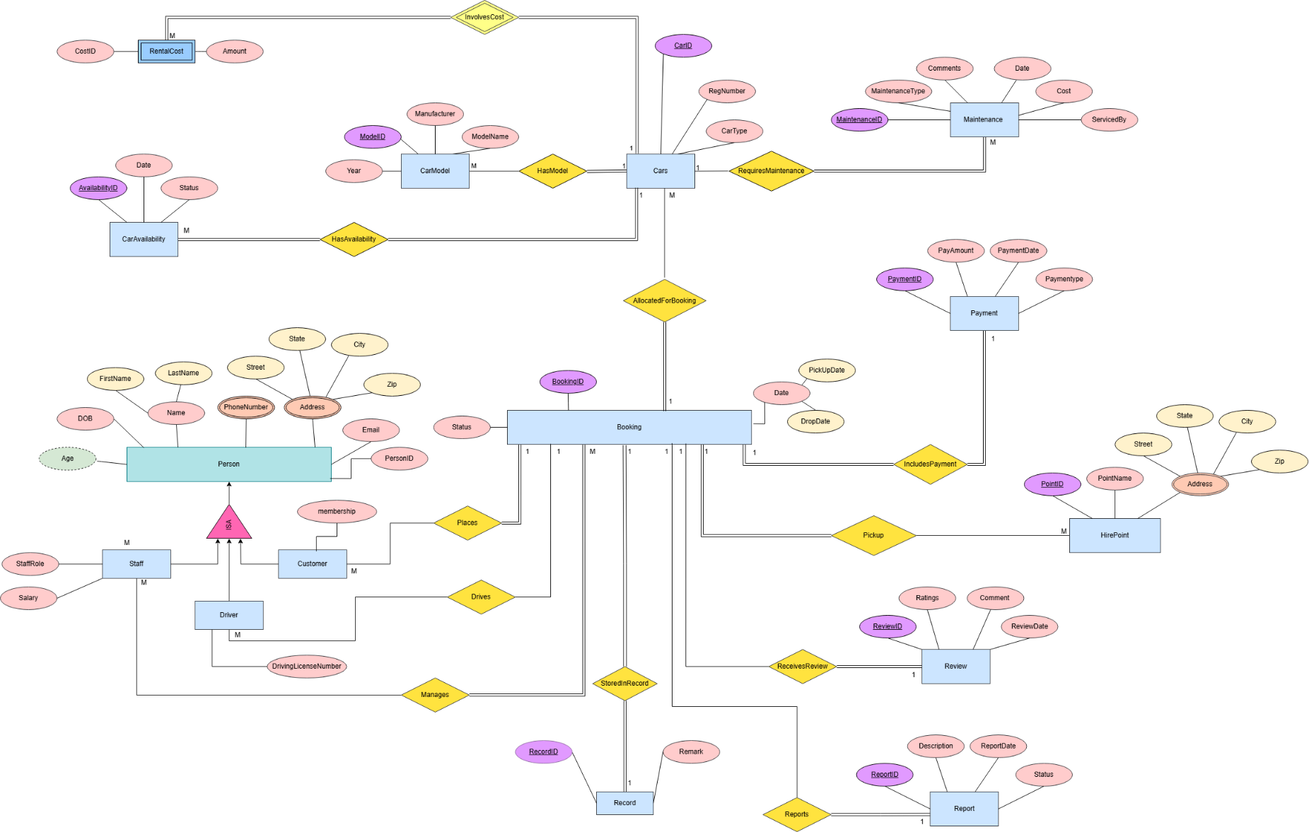

# A screenshot of a computer Description automatically generatedSchema Design of the Project

# Implementation Checklist

|  |  |
| --- | --- |
| Description | Remarks |
| Project Type | Application |
| Project Platform | Windows |
| Programming language | Dart |
| Framework | Flutter |
| Database type | Local using Xampp |
| API | Using PHP Language |
|  |  |
| Authentication Type | Custom |
|  |  |
| Number of Pages with Forms | 07 |
| Number of Pages based on Queries, Aggregate Queries | 21 |
|  |  |
| Included any trigger/other feature which is not taught in class. If yes, please explain briefly. | 1. We have used auto increment features to generate ID’s automatically. 2. We have used insert_id function to get the last generated id. |
| Write the most unique feature/functionality in your application or the page of your application that you are proud of. Explain briefly. | There are so many unique features in our application as our application is a windows application & we have used many advanced UI/UX features.  We did not use oracle apex rather we have built our custom UI. |

# Pages with user input

|  |  |  |
| --- | --- | --- |
| **Page Type** | **Description** | **Table** |
| Sign up | This page is for signing up with user data. | person, customer, driver, staff. |
| Log in | Admin, user, driver can log in to there account with their proper user name & password. | person, customer, driver, staff. |
| Add Cars | Admin add new cars with all required information into database. | cars, carmodel, caravailbility, rentalcost. |
| Add Booking | User rent their desired car in this page. | booking, hirepoint, driver. |
| Payment | User select their payment method & complete their payment to confirm their booking. | payment. |
| Add Review | User can add review of their overall experience. | review, booking. |
| Add Report | User can report about any specific issue regarding their booking. | report, booking. |

Figure 4.1:

Figure 4.2:

Figure 4.3:

Figure 4.4:

Figure 4.5:

* 

Figure 4.6:

Figure 4.7:

# Pages based on Multi-Table and Aggregate Queries

|  |  |  |
| --- | --- | --- |
| **Page Type** | **Query Type** | **Report description** |
| Home page | Multi-Table Query | It shows all car type, also shows the popular cars. |
| Filtered Cars | Multi-Table Query | It shows all cars of that specific type. |
| Show All Available Car | Multi-Table Query | It shows all available cars for booking. |
| On going | Multi-Table Nested-Query | Shows all current active bookings of a specific user. |
| Review | Multi-Table Query | Shows all the reviews of a specific user. |
| Report | Simple Query | Shows all the reports submitted by a specific user. |
| Cancelled | Simple Query | Shows all cancelled bookings by a specific user. |
| My Profile | Multi-Table Query | Shows all information of specific user/driver/admin including their unique information related to their role. |
| Dashboard | Multi-Table Query & Aggregation | To show company’s total user, available car, total revenue. |
| View All Cars | Multi-Table Query | Used by admin to add new cars to the database also to see cars information about availability, rent , model e.t.c. |
| View All Persons | Simple Query | To show all the admin, users, drivers, staffs information. |
| View All Customers | Nested Query | To show all the customers information of the database. |
| View All Payments | Simple Query | Shows all payment details of each bookings. |
| View All Reports | Simple Query | Shows all reports made by customers. |
| View All Hire points | Simple Query | Shows company’s all hire point details. |
| View All Maintenance Record | Nested Query | Shows all information of every maintenance. |
| View All Review Records | Multi-Table Query | Shows all booking related reviews made by customers. |
| View All Booking Details | Multi-Table Query | Shows everything related to each booking. |
| Booking Count Total Spend | Multi-Table Query & Aggregation | Shows total spend of each customer for all bookings from this company. |
| Show All Popular Car | Multi-Table Query & Aggregation | Shows all popular cars of the company based on customer ratings. |

Figure 6.1:

(Side Nav-Bar)

Figure 6.2:

Figure 6.3:

Figure 6.4:

Figure 6.5:

Figure 6.6:

Figure 6.7:

Figure 6.8:

(Customer Profile)

(Driver Profile)

(Staff Profile)

Figure 6.9:

Figure 6.10:

Figure 6.11:

Figure 6.12:

Figure 6.13:

Figure 6.14:

Figure 6.15:

Figure 6.17:

Figure 6.18:

Figure 6.19:

Figure 6.20:

Figure 6.21:

# Authorization and User Role Assignment

**User Role Assignment**

|  |  |  |
| --- | --- | --- |
| **User name** | **Password** | **Role** |
| xhafan | 1234 | Admin |
| michael | 1234 | Admin |
| sarah | 1234 | Admin |
| john | 1234 | Customer |
| nayna | 1234 | Customer |
| muabsshir | 1234 | Customer |
| israt | 1234 | Customer |
| laura | 1234 | Driver |
| david | 1234 | Driver |

There are more users in our database.

# Concluding Remarks

During building this project we have seen the real-life implementation of database & learned how it works & database management procedure.

We also learned about building windows application with database in backend.

Overall experience was good but due to shortage of time we couldn’t show our proper potential & creativity but eventually we manage to finish our project.

Thank you for the encouragement- this journey has been worth every moment.